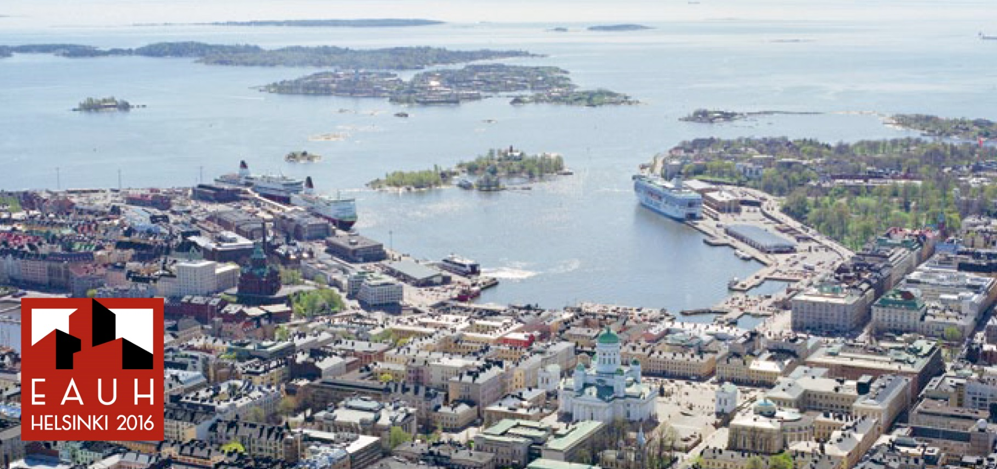

EAUH 2016 Helsinki - Reinterpreting Cities

CALL FOR SESSIONS
The 13th International Conference on Urban History ‘Reinterpreting Cities’ will take place in Helsinki from the 24th to the 27th of August 2016.
The call for session proposals is now open until March 1, 2015. Proposals can be submitted on the website https://eauh2016.net/ - and session organisers will be notified of decisions regarding acceptance in May 2015.
The European Association for Urban History encourages cross-disciplinary and international research on urban history. Therefore the Association invites you to submit sessions that are as comparative and interdisciplinary as possible. Furthermore, we give priority to sessions, which are co-organised by scholars from different countries.

